- Cymbal Bank needs to connect its employee MongoDB database to a new human resources web application on the same network. Both the database and the application are autoscaled with the help of Instance templates. As the Security Administrator and Project Editor, you have been tasked with allowing the application to read port 27017 on the database. What should you do?
checkCreate service accounts for the application and database. Create a firewall rule using:gcloud compute firewall-rules create ALLOW_MONGO_DB --network network-name --allow TCP:27017 --source-service-accounts web-application-service-account --target-service-accounts database-service-account
- Cymbal Bank has published an API that internal teams will use through the Application Load Balancer. You need to limit the API usage to 200 calls every hour. Any exceeding usage should inform the users that servers are busy. Which gcloud command would you run to throttle the load balancing for the given specification?
checkgcloud compute security-policies rules create priority --security-policy sec-policy --src-ip-ranges=source-range --action=throttle --rate-limit-threshold-count=200 --rate-limit-threshold-interval-sec=3600 --conform-action=allow --exceed-action=deny-429 --enforce-on-key=HTTP-HEADER
- Cymbal Bank’s Customer Details API runs on a Compute Engine instance with only an internal IP address. Cymbal Bank’s new branch is co-located outside the Google Cloud points-of-presence (PoPs) and requires a low-latency way for its on-premises apps to consume the API without exposing the requests to the public internet. Which solution would you recommend?
checkUse Partner Interconnect. Use a service provider to access their enterprise grade infrastructure to connect to the Google Cloud environment.
- Cymbal Bank has designed an application to detect credit card fraud that will analyze sensitive information. The application that’s running on a Compute Engine instance is hosted in a new subnet on an existing VPC. Multiple teams who have access to other VMs in the same VPC must access the VM. You want to configure the access so that unauthorized VMs or users from the internet can’t access the fraud detection VM. What should you do?
Use subnet isolation. Create a service account for the fraud detection engine. Create service accounts for each of the teams’ Compute Engine instances that will access the engine. Add a firewall rule using: gcloud compute firewall-rules create ACCESS_FRAUD_ENGINE –network
- Cymbal Bank is releasing a new loan management application using a Compute Engine managed instance group. External users will connect to the application using a domain name or IP address protected with TLS 1.2. A load balancer already hosts this application and preserves the source IP address. You are tasked with setting up the SSL certificate for this load balancer. What should you do?
Create a Google-managed SSL certificate. Attach a global static external IP address to the global external Application Load Balancer. Validate that an existing URL map will route the incoming service to your managed instance group backend. Load your certificate and create an HTTPS proxy routing to your URL map. Create a global forwarding rule that routes incoming requests to the proxy.
- The data from Cymbal Bank’s loan applicants resides in a shared VPC. A credit analysis team uses a CRM tool hosted in the App Engine standard environment. You need to provide credit analysts with access to this data. You want the charges to be incurred by the credit analysis team. What should you do?
Add ingress firewall rules to allow NAT and Health Check ranges for the App Engine standard environment in the Shared VPC network. Create a client-side connector in the Service Project using the Shared VPC Project ID. Verify that the connector is in a READY state. Create an ingress rule on the Shared VPC network to allow the connector using Network Tags or IP ranges.
- You have recently joined Cymbal Bank as a cloud engineer. You created a custom VPC network, selecting to use the automatic subnet creation mode and nothing else. The default network still exists in your project. You create a new Linux VM instance and select the custom VPC as the network interface. You try to SSH into your instance, but you are getting a “connection failed” error. What answer best explains why you cannot SSH into the instance?
checkYou did not set up any firewall rules on your custom VPC network. While the default VPC comes with a predefined firewall rule that allows SSH traffic, these need to be added to any custom VPCs.
- An ecommerce portal uses Google Kubernetes Engine to deploy its recommendation engine in Docker containers. This cluster instance does not have an external IP address. You need to provide internet access to the pods in the Kubernetes cluster. What configuration would you add?
checkCloud NAT gateway, subnet primary IP address range for nodes, and subnet secondary IP address range for pods and services in the cluster
- An external audit agency needs to perform a one-time review of Cymbal Bank’s Google Cloud usage. The auditors should be able to access a Default VPC containing BigQuery, Cloud Storage, and Compute Engine instances where all the usage information is stored. You have been tasked with enabling the access from their on-premises environment, which already has a configured VPN. What should you do?
checkUse a Cloud VPN tunnel. Use Cloud DNS to create DNS zones and records for *.googleapis.com. Set up on-premises routing with Cloud Router. Use Cloud Router custom route advertisements to announce routes for Google Cloud destinations.
- Your organization has a website running on Compute Engine. This instance only has a private IP address. You need to provide SSH access to an on-premises developer who will debug the website from the authorized on-premises location only. How do you enable this?
checkUse Identity-Aware Proxy (IAP). Set up IAP TCP forwarding by creating ingress firewall rules on port 22 for TCP using the gcloud command.

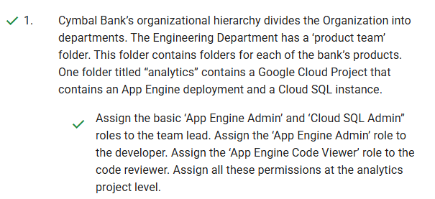

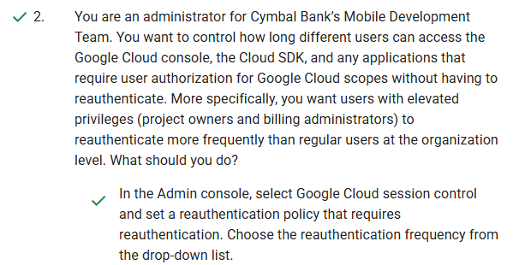

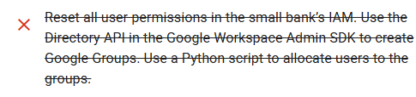
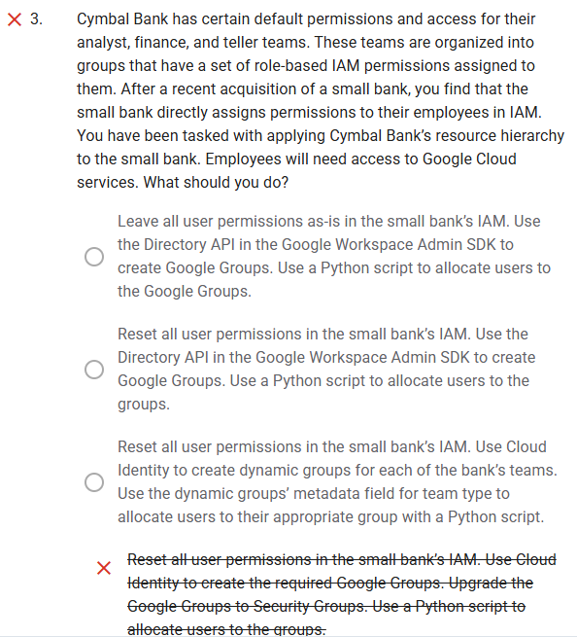

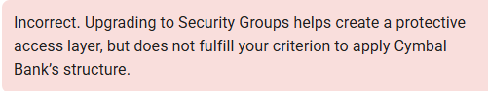
Incorrect. Using Google Groups from the Workspace Admin SDK Directory APIs allows access to Google Drive and Docs, but not to Google Cloud resources.
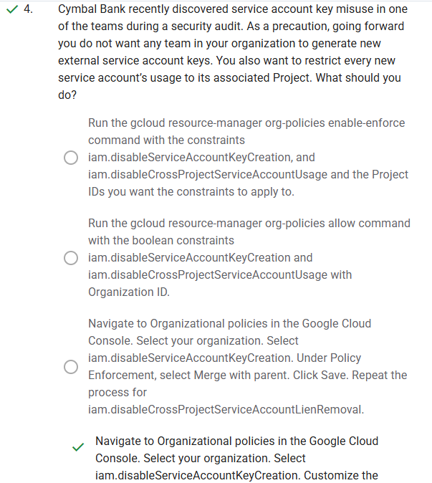

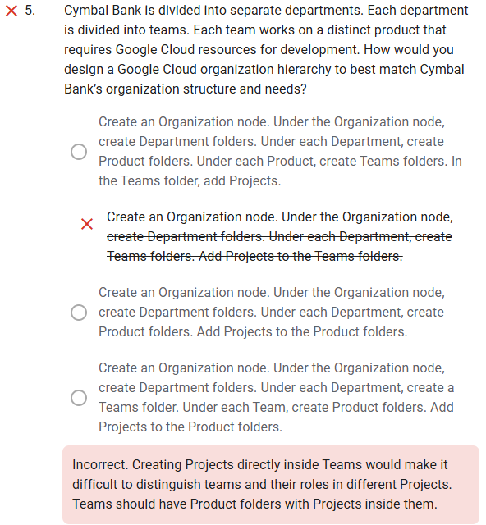

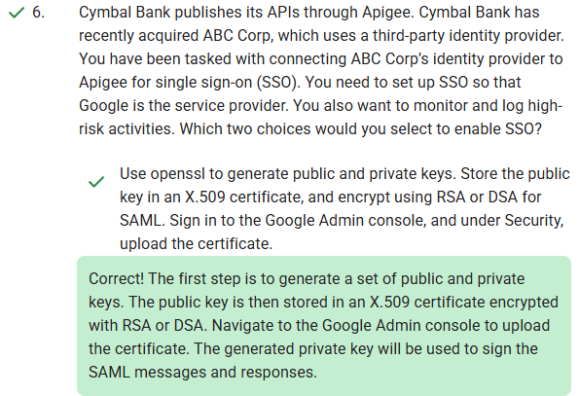

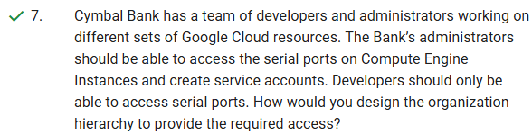

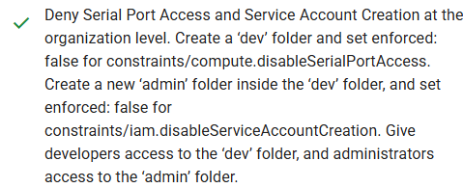

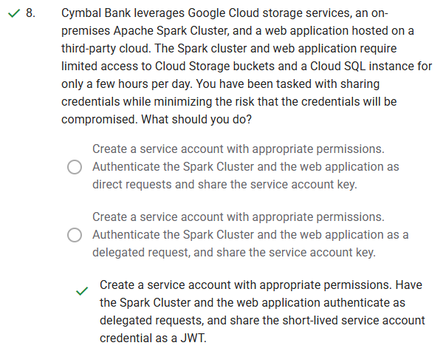

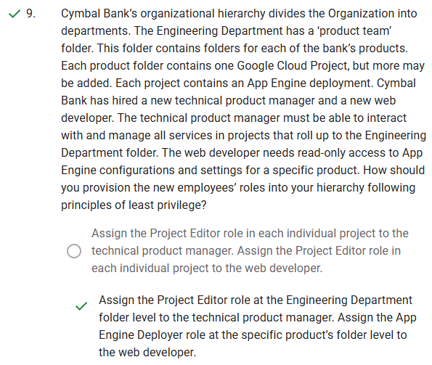

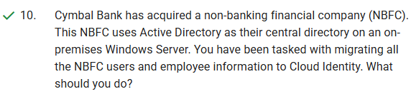

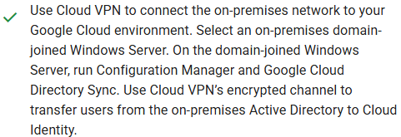

Diagnostic questions
Your score: 90% Passing score: 80%
Congratulations! You passed this assessment.
check
1.
Cymbal Bank has hired a data analyst team to analyze scanned copies of loan applications. Because this is an external team, Cymbal Bank does not want to share the name, gender, phone number, or credit card numbers listed in the scanned copies. You have been tasked with hiding this PII information while minimizing latency. What should you do?
Use the Cloud Vision API to perform optical code recognition (OCR) from scanned images. Redact the text using the Cloud Natural Language API with regular expressions.
Use the Cloud Vision API to perform text extraction from scanned images. Redact the text using the Cloud Natural Language API with regular expressions.
checkUse the Cloud Data Loss Prevention (DLP) API to make redact image requests. Provide your project ID, built-in infoTypes, and the scanned copies when you make the requests.
Use the Cloud Vision API to perform optical code recognition (OCR) from scanned images. Redact the text using the Cloud Data Loss Prevention (DLP) API with regular expressions.
Correct! The DLP API can be directly used for image redaction. Built-in infoTypes already include name, gender, phone number, and credit card numbers.
check
2.
Cymbal Bank stores customer information in a BigQuery table called ‘Information,’ which belongs to the dataset ‘Customers.’ Various departments of Cymbal Bank, including loan, credit card, and trading, access the information table. Although the data source remains the same, each department needs to read and analyze separate customers and customer-attributes. You want a cost-effective way to configure departmental access to BigQuery to provide optimal performance. What should you do?
Create separate datasets for each department. Create authorized functions in each dataset to perform required aggregations. Write transformed data to new tables for each department separately. Provide the bigquery.dataViewer role to each department’s required users.
checkCreate separate datasets for each department. Create views for each dataset separately. Authorize these views to access the source dataset. Share the datasets with departments. Provide the bigquery.dataViewer role to each department’s required users.
Create an authorized dataset in BigQuery’s Explorer panel. Write Customers’ table metadata into a JSON file, and edit the file to add each department’s Project ID and Dataset ID. Provide the bigquery.user role to each department’s required users.
Secure data with classification. Open the Data Catalog Taxonomies page in the Google Cloud Console. Create policy tags for required columns and rows. Provide the bigquery.user role to each department’s required users. Provide policy tags access to each department separately.
Correct! Using authorized views is the right approach. Create a separate dataset for each department, and provide access to views containing filtered rows and columns.
close
3.
Cymbal Bank needs to migrate existing loan processing applications to Google Cloud. These applications transform confidential financial information. All the data should be encrypted at all stages, including sharing between sockets and RAM. An integrity test should also be performed every time these instances boot. You need to use Cymbal Bank’s encryption keys to configure the Compute Engine instances. What should you do?
Create a Confidential VM instance with Customer-Supplied Encryption Keys. In Cloud Logging, collect all logs for sevLaunchAttestationReportEvent.
Create a Shielded VM instance with Customer-Managed Encryption Keys. In Cloud Logging, collect all logs for sevLaunchAttestationReportEvent.
Create a Shielded VM instance with Customer-Supplied Encryption Keys. In Cloud Logging, collect all logs for earlyBootReportEvent.
closeCreate a Confidential VM instance with Customer-Managed Encryption Keys. In Cloud Logging, collect all logs for earlyBootReportEvent.
Incorrect. Customer-Managed Encryption Keys will only let you manage key rotation, but you need to use your own encryption keys. Use the launch attestation event from Cloud Logging because earlyBootReportEvent is not the parameter for booting.
check
4.
You are tasked with developing an AI system on Google Cloud for a telecommunications business. This AI system will conduct sentiment analysis on conversations agents have with customers, and provide conversational recommendations to improve customer satisfaction in the future. What AI/ML-specific security controls do you need to plan for when developing this system?
Deploy your AI solution using managed instance groups (MIGs). These have baked in security controls specific to running AI workloads.
Leverage an AI model-specific threat detection scanner. Threats between AI systems and non-AI systems have very little in common.
checkAI systems are more interconnected than non-AI systems. Prepare for new attack vectors, as attackers can exploit vulnerabilities in one system to attack another.
Select Google Cloud AI services that leverage a PaaS model. These are the only ones that can guarantee a secure-by-design foundation.
Correct! AI systems are more interconnected. AI systems are often connected to other systems, inside and outside of an organization. This interconnectedness can create new attack vectors, as attackers can exploit vulnerabilities in one system to attack another.
check
5.
Cymbal Bank needs to statistically predict the days customers delay the payments for loan repayments and credit card repayments. Cymbal Bank does not want to share the exact dates a customer has defaulted or made a payment with data analysts. Additionally, you need to hide the customer name and the customer type, which could be corporate or retail. How do you provide the appropriate information to the data analysts?
Generalize all dates to year and month with bucketing. Use the built-in infoType for customer name. Use a custom infoType for customer type with regular expression.
Generalize all dates to year and month with date shifting. Use a predefined infoType for customer name. Use a custom infoType for customer type with regular expression.
checkGeneralize all dates to year and month with date shifting. Use a predefined infoType for customer name. Use a custom infoType for customer type with a custom dictionary.
Generalize all dates to year and month with bucketing. Use the built-in infoType for customer name. Use a custom infoType for customer type with a custom dictionary.
Correct! If your data is stored in a valid schema, date shifting will shift all dates logically. Built-in infoTypes allow a range of locale-specific and globally identifiable sensitive information pieces like email IDs and phone numbers. Custom dictionaries can be used with a custom infoType that contains predefined key-value pairs.
check
6.
Cymbal Bank uses Google Kubernetes Engine (GKE) to deploy its Docker containers. You want to encrypt the boot disk for a cluster running a custom image so that the key rotation is controlled by the Bank. GKE clusters will also generate up to 1024 randomized characters that will be used with the keys with Docker containers. What steps would you take to apply the encryption settings with a dedicated hardware security layer?
checkCreate a new GKE cluster with customer-managed encryption and HSM enabled. Deploy the containers to this cluster. Delete the old GKE cluster. Use Cloud HSM to generate random bytes and provide an additional layer of security.
Create a new key ring using Cloud Key Management Service. Extract this key to a certificate. Use the kubectl command to update the Kubernetes configuration. Validate using MAC digital signatures, and use a startup script to generate random bytes.
Create a new key ring using Cloud Key Management Service. Extract this key to a certificate. Use the Google Cloud Console to update the Kubernetes configuration. Validate using MAC digital signatures, and use a startup script to generate random bytes.
In the Google Cloud console, navigate to Google Kubernetes Engine. Select your cluster and the boot node inside the cluster. Enable customer-managed encryption. Use Cloud HSM to generate random bytes and provide an additional layer of security.
Correct! Building a new cluster and deleting the old one is the solution. Cloud HSM provides an additional layer of dedicated hardware security and generates random bytes of up to 1024 characters.
check
7.
You're building a machine learning model on Google Cloud. You're choosing between two options: managing the infrastructure yourself (IaaS) or using Google's managed services (PaaS). To ensure the best security posture for both the model and its data, which TWO factors should you prioritize when defining security requirements for each hosting option?
Compliance with internal security policies
Network traffic inspection and intrusion detection
checkGranular access controls and permissions
Correct! Controlling who accesses the model and data is crucial for securing both IaaS and PaaS environments.
checkData location and residency restrictions
Correct! In PaaS, Google manages the infrastructure, so you need to ensure data residency aligns with your compliance and privacy requirements.
Physical server hardening and security patchescheck
8.
Cymbal Bank has a Cloud SQL instance that must be shared with an external agency. The agency’s developers will be assigned roles and permissions through a Google Group in Identity and Access Management (IAM). The external agency is on an annual contract and will require a connection string, username, and password to connect to the database. How would you configure the group’s access?
Use Secret Manager. Use the resource attribute to set a key-value pair with key as duration and values as expiry period one year from now. Add secretmanager.viewer role for the group that contains external developers.
checkUse Secret Manager. Use the duration attribute to set the expiry period to one year. Add the secretmanager.secretAccessor role for the group that contains external developers.
Use Cloud Key Management Service. Use the destination IP address and Port attributes to provide access for developers at the external agency. Remove the IAM access after one year and rotate the shared keys. Add cloudkms.cryptoKeyEncryptorDecryptor role for the group that contains the external developers.
Use Secret Manager for the connection string and username, and use Cloud Key Management Service for the password. Use tags to set the expiry period to the timestamp one year from now. Add secretmanager.secretVersionManager and secretmanager.secretAccessor roles for the group that contains external developers.
Correct! Secret Manager supports time types such as absolute time duration to invoke and revoke access. The Secret Assessor role is required to read the stored secrets in Secret Manager.
check
9.
You are building an AI model on Google Cloud to analyze customer data and predict purchase behavior. This model will have access to sensitive information like purchase history and demographics. To protect this data and prevent misuse of the model, what THREE security controls are most important to implement?
checkDeploy the model in a region with the highest data security standards.
Correct! This ensures compliance with regional regulations and data residency requirements, further safeguarding sensitive customer information.
Configure IAM roles to grant full access to the model for all Google Cloud users.
checkEnable Google Cloud Armor on your deployed model to block malicious requests.
Correct! This actively protects the model from external threats and unauthorized access attempts, which is crucial for preventing data exploitation.
checkMonitor the model's performance for anomalies and biases, then manually intervene if needed.
Correct! Proactive monitoring and human oversight are essential for detecting potential misuse, bias, or unintended consequences of the AI model.
Store all model training data in BigQuery with public access for transparency.check
10.
Cymbal Bank calculates employee incentives on a monthly basis for the sales department and on a quarterly basis for the marketing department. The incentives are released with the next month’s salary. Employee’s performance documents are stored as spreadsheets, which are retained for at least one year for audit. You want to configure the most cost-effective storage for this scenario. What should you do?
checkUpload the spreadsheets to Cloud Storage. Select the Nearline storage class for the sales department and Coldline storage for the marketing department. Use object lifecycle management rules to set the storage class to Archival after 365 days. Process the data on BigQuery using jobs that run monthly for Sales and quarterly for Marketing.
Import the spreadsheets into Cloud Storage and create NoSQL tables. Use App Engine cron jobs to run monthly for Sales and quarterly for Marketing. Use a separate job to delete the data after 1 year.
Import the spreadsheets to BigQuery, and create separate tables for Sales and Marketing. Set table expiry rules to 365 days for both tables. Create jobs scheduled to run every quarter for Marketing and every month for Sales.
Import the spreadsheets to Cloud SQL, and create separate tables for Sales and Marketing. For Table Expiration, set 365 days for both tables. Use stored procedures to calculate incentives. Use App Engine cron jobs to run stored procedures monthly for Sales and quarterly for Marketing.
Correct! Cloud Storage storage classes let you lower the storage cost for data that you access less frequently and don’t require for real-time applications. Use object lifecycle rules to change storage classes and expire data. For processing, use BigQuery, which has a free daily quota.

Diagnostic questions
Your score: 90% Passing score: 80%
Congratulations! You passed this assessment.
close
1.
Cymbal Bank uses Docker containers to interact with APIs for its personal banking application. These APIs are under PCI-DSS compliance. The Kubernetes environment running the containers will not have internet access to download required packages. How would you automate the pipeline that is building these containers?
Build a foundation image. Store all artifacts and a Packer definition template in a Git repository. Use Artifact Registry to build the artifacts and Packer definition. Use Cloud Build to extract the built container and deploy it to a Google Kubernetes Engine (GKE) cluster. Add the required users and groups to the GKE project.
closeBuild an immutable image. Store all artifacts and a Packer definition template in a Git repository. Use Artifact Registry to build the artifacts and Packer definition. Use Cloud Build to extract the built container and deploy it to a Google Kubernetes Engine Cluster (GKE). Add the required users and groups to the GKE project.
Create a Dockerfile with a container definition and a Cloud Build configuration file. Use the Cloud Build configuration file to build and deploy the image from Dockerfile to Artifact Registry. In the configuration file, include the Google Container Registry path and the Google Kubernetes Engine cluster. Upload the configuration file to a Git repository. Create a trigger in Cloud Build to automate the deployment using the Git repository.
Create a Dockerfile with container definition and cloudbuild.yaml file. Use Cloud Build to build the image from Dockerfile. Upload the built image to Artifact Registry and Dockerfile to a Git repository. In the cloudbuild.yaml template, include attributes to tag the Git repository path with a Google Kubernetes Engine cluster. Create a trigger in Cloud Build to automate the deployment using the Git repository.
Incorrect. You need to build a pipeline, so Cloud Build standalone is not a solution. Use a CI/CD pipeline creator such as Jenkins. However, creating an immutable image for the container is the right choice.
check
2.
Cymbal Bank’s management is concerned about virtual machines being compromised by bad actors. More specifically, they want to receive immediate alerts if there have been changes to the boot sequence of any of their Compute Engine instances. What should you do?
checkSet an organization-level policy that requires all Compute Engine VMs to be configured as Shielded VMs. Use Measured Boot enabled with Virtual Trusted Platform Module (vTPM). Validate integrity events in Cloud Monitoring and place alerts on late boot validation events.
Set project-level policies that require all Compute Engine VMs to be configured as Shielded VMs. Use Measured Boot enabled with Virtual Trusted Platform Module (vTPM). Validate integrity events in Cloud Monitoring and place alerts on late boot validation events.
Set Cloud Logging measurement policies on the VMs. Use Cloud Logging to place alerts whenever actualMeasurements and policyMeasurements don’t match.
Set an organization-level policy that requires all Compute Engine VMs to be configured as Shielded VMs. Use Secure Boot enabled with Unified Extensible Firmware Interface (UEFI). Validate integrity events in Cloud Monitoring and place alerts on launch attestation events.
Correct! Shielded VMs support Integrity Monitoring, which determines whether a VM instance's boot sequence has changed. The integrity baseline policy is created when you boot a VM for the first time. Every subsequent reboot will now generate and compare Early Boot and Late Boot events against the integrity baseline policy.
check
3.
Cymbal Bank runs a Node.js application on a Compute Engine instance. Cymbal Bank needs to share this base image with a ‘development’ Google Group. This base image should support secure boot for the Compute Engine instances deployed from this image. How would you automate the image creation?
Start the Compute Engine instance. Set up certificates for secure boot. Prepare a cloudbuild.yaml configuration file. Specify the persistent disk location of the Compute Engine and the ‘development’ group. Use the command gcloud builds submit --tag, and specify the configuration file path and the certificates.
Stop the Compute Engine instance. Set up Measured Boot for secure boot. Prepare a cloudbuild.yaml configuration file. Specify the persistent disk location of the Compute Engine instance and the ‘development’ group. Use the command gcloud builds submit --tag, and specify the configuration file path.
checkPrepare a shell script. Add the command gcloud compute instances stop with the Node.js instance name. Set up certificates for secure boot. Add gcloud compute images create, and specify the Compute Engine instance’s persistent disk and zone and the certificate files. Add gcloud compute images add-iam-policy-binding and specify the ‘development’ group.
Prepare a shell script. Add the command gcloud compute instances start to the script to start the Node.js Compute Engine instance. Set up Measured Boot for secure boot. Add gcloud compute images create, and specify the persistent disk and zone of the Compute Engine instance.
Correct! You need to stop the Compute Engine instance before creating the image. Use the command gcloud compute images create with the instance's disk and zone. Secure boot requires setting up certificates to establish trust between platform, firmware, and OS.
check
4.
The loan application from Cymbal Bank’s lending department collects credit reports that contain credit payment information from customers. According to bank policy, the PDF reports are stored for six months in Cloud Storage, and access logs for the reports are stored for three years. You need to configure a cost-effective storage solution for the access logs. What should you do?
Set up a logging export bucket in Cloud Storage to collect data from the Security Command Center. Configure object lifecycle management rules to delete logs after three years.
Set up a logging export dataset in BigQuery to collect data from Cloud Logging and the Security Command Center. Create table expiry rules to delete logs after three years.
Set up a logging export dataset in BigQuery to collect data from Cloud Logging and Cloud Monitoring. Create table expiry rules to delete logs after three years.
checkSet up a logging export bucket in Cloud Storage to collect data from Cloud Audit Logs. Configure object lifecycle management rules to delete logs after three years.
Correct! Cloud Audit Logs has provisions for data access logs that are required in this scenario. Cloud Storage provides the most cost-effective storage solution.
check
5.
Cymbal Bank needs a secure, compliant DevSecOps solution on Google Cloud for vulnerability scanning, granular access control, and cryptographic key management. They also require dynamic artifact analysis triggered by metadata changes. Which Google Cloud services best meet these stringent requirements?
Custom artifact storage on Compute Engine with Binary Authorization for policy enforcement, combined with independent vulnerability scanning tools deployed on Google Kubernetes Engine, and integrated with Cloud Logging for audit trails.
Compute Engine instances running custom vulnerability scanning scripts, secured with VPC Service Controls, and managed using Cloud Deployment Manager with Terraform modules for infrastructure as code.
checkArtifact Registry with Artifact Analysis, leveraging IAM Conditions for fine-grained access control and Cloud KMS for Customer-Managed Encryption Keys, integrated with Cloud Build triggers based on Pub/Sub notifications from Artifact Registry.
Cloud Storage with Object Lifecycle Management for artifact versioning, integrated with Cloud Functions triggered by object creation events for ad-hoc vulnerability checks, and secured with IAM roles based on least privilege.
Correct! Artifact Registry and Artifact Analysis offer a complete, secure, and compliant solution with centralized artifact storage, native vulnerability scanning, granular access control via IAM Conditions, CMEK via Cloud KMS, and automated responses to changes through Pub/Sub and Cloud Build triggers.
check
6.
Cymbal Bank has Docker applications deployed in Google Kubernetes Engine. The bank has no offline containers. This GKE cluster is exposed to the public internet and has recently recovered from an attack. Cymbal Bank suspects that someone in the organization changed the firewall rules and has tasked you to analyze and find all details related to the firewall for the cluster. You want the most cost-effective solution for this task. What should you do?
View the GKE logs in the local GKE cluster. Use Docker-explorer to explore the Docker file system. Filter and export the Firewall logs to Cloud Logging. Create a dataset in BigQuery to accept the logs. Use the command gcloud logging sinks create to export the logs to a BigQuery dataset. Query this dataset.
View the GKE logs in the local GKE cluster. Use the kubectl Sysdig Capture tool to filter the Firewall Rules log. Create a Pub/Sub topic. Export these logs to a Pub/Sub topic using the GKE cluster. Use Dataflow to read from Pub/Sub and query the stream.
View the GKE logs in Cloud Logging. Use the log scoping tool to filter the Firewall Rules log. Create a Pub/Sub topic. Export the logs to a Pub/Sub topic using the command gcloud logging sinks create. Use Dataflow to read from Pub/Sub and query the stream.
checkView the GKE logs in Cloud Logging. Use the log scoping tool to filter the Firewall Rules log. Create a dataset in BigQuery to accept the logs. Export the logs to BigQuery using the command gcloud logging sinks create. Query this dataset.
Correct! Cloud Logging is enabled by default for GKE clusters. The Firewall Rules log captures all changes made to the firewall. BigQuery can be used to capture the data and analyze it using the free quota.
check
7.
Cymbal Bank has suffered a remote botnet attack on Compute Engine instances in an isolated project. The affected project now requires investigation by an external agency. An external agency requests that you provide all admin and system events to analyze in their local forensics tool. You want to use the most cost-effective solution to enable the external analysis. What should you do?
Use the Security Command Center. Select Cloud Logging as the source, and filter by category: Admin Activity and category: System Activity. View the Source property of the Finding Details section. Use Pub/Sub topics to export the findings to the external agency’s forensics tool.
Use Cloud Monitoring and Cloud Logging. Filter Cloud Monitoring to view only system and admin logs. Expand the system and admin logs in Cloud Logging. Use Pub/Sub to export the findings from Cloud Logging to the external agency’s forensics tool or storage.
checkUse Cloud Audit Logs. Filter Admin Activity audit logs for only the affected project. Use a Pub/Sub topic to stream the logs from Cloud Audit Logs to the external agency’s forensics tool.
Use Event Threat Detection. Trigger the IAM Anomalous Grant detector to detect all admins and users with admin or system permissions. Export these logs to the Security Command Center. Give the external agency access to the Security Command Center.
Correct! Cloud Audit Logs by default has admin and system activity logged. Filter the logs and use a Pub/Sub topic to send the logs to the external agency’s forensics tool.
check
8.
Cymbal Bank wants to use Cloud Storage and BigQuery to store safe deposit usage data. Cymbal Bank needs a cost-effective approach to auditing only Cloud Storage and BigQuery data access activities. How would you use Cloud Audit Logs to enable this analysis?
checkEnable Data Access Logs for ADMIN_READ, DATA_READ, and DATA_WRITE for Cloud Storage. All Data Access Logs are enabled for BigQuery by default.
Enable Data Access Logs for ADMIN_READ, DATA_READ, and DATA_WRITE at the organization level.
Enable Data Access Logs for ADMIN_READ, DATA_READ, and DATA_WRITE at the service level for BigQuery and Cloud Storage.
Enable Data Access Logs for ADMIN_READ, DATA_READ, and DATA_WRITE for BigQuery. All Data Access Logs are enabled for Cloud Storage by default.
Correct! Cloud Storage must be configured for Cloud Audit Logging, but BigQuery is enabled by default.
check
9.
Cymbal Bank experienced a recent security issue. A rogue employee with admin permissions for Compute Engine assigned existing Compute Engine users some arbitrary permissions. You are tasked with finding all these arbitrary permissions. What should you do to find these permissions most efficiently?
checkUse Event Threat Detection and trigger the IAM Anomalous grants detector. Publish results to the Security Command Center. In the Security Command Center, select Event Threat Detection as the source, filter by category: iam, and sort to find the attack time window. Click on Persistence: IAM Anomalous Grant to display Finding Details. View the Source property of the Finding Details section.
Use Event Threat Detection and trigger the IAM Anomalous Grant detector. Publish results to Cloud Logging. In the Security Command Center, select Cloud Logging as the source, filter by category: anomalies, and sort to find the attack time window. Click on Persistence: IAM Anomalous Grant to display Finding Details. View the Source property of the Finding Details section.
Use Event Threat Detection and configure Continuous Exports to filter and write only Firewall logs to the Security Command Center. In the Security Command Center, select Event Threat Detection as the source, filter by category: anomalies, and sort to find the attack time window. Click on Evasion: IAM Anomalous Grant to display Finding Details. View the Source property of the Finding Details section.
Use Event Threat Detection and configure Continuous Exports to filter and write only Firewall logs to the Security Command Center. In the Security Command Center, select Event Threat Detection as the source, filter by evasion: Iam, and sort to find the attack time window. Click on Persistence: IAM Anomalous Grant to display Finding Details. View the Source property of the Finding Details section.
Correct! Event Threat Detection has triggers that detect anomalies on specified filters. Event Threat Detection can publish results to the Security Command Center. From the Security Command Center, filter and navigate to find all anomalies for the affected users.
check
10.
Cymbal Bank uses Compute Engine instances for its APIs, and recently discovered bitcoin mining activities on some instances. The bank wants to detect all future mining attempts and notify the security team. The security team can view the Security Command Center and Cloud Audit Logs. How should you configure the detection and notification?
checkEnable Anomaly Detection in the Security Command Center. Create and configure a Pub/Sub topic and an email service. Create a Cloud Run function to send email notifications for suspect activities. Export findings to a Pub/Sub topic, and use them to invoke the Cloud Run function.
Enable the Web Security Scanner in the Security Command Center. Perform a scan of Compute Engine instances. Publish results to Cloud Audit Logging. Create an alert in Cloud Monitoring to send notifications for suspect activities.
Enable the VM Manager tools suite in the Security Command Center. Perform a scan of Compute Engine instances. Publish results to Cloud Audit Logging. Create an alert in Cloud Monitoring to send notifications of suspect activities.
Use Event Threat Detection’s threat detectors. Export findings from ‘Suspicious account activity’ and ‘Anomalous IAM behavior’ detectors and publish them to a Pub/Sub topic. Create a Cloud Run function to send notifications of suspect activities. Use Pub/Sub notifications to invoke the Cloud Run function.
Correct! You should enable Anomaly Detection in the Security Command Center. Use Pub/Sub topics to export the findings. Cloud Run functions can then be used to send out any form of notification.

Diagnostic questions
Your score: 100% Passing score: 80%
Congratulations! You passed this assessment.
check
1.
Cymbal Bank’s lending department stores sensitive information, such as your customers’ credit history, address and phone number, in parquet files. You need to upload this personally identifiable information (PII) to Cloud Storage so that it’s secure and compliant with ISO 27018. How should you protect this sensitive information using Cymbal Bank’s encryption keys and using the least amount of computational resources?
checkGenerate an AES-256 key as a 32-byte bytestring. Decode it as a base-64 string. Upload the blob to the bucket using this key.
Generate a customer-managed encryption key (CMEK) using RSA or AES256 encryption. Decode it as a base-64 string. Upload the blob to the bucket using this key.
Generate a customer-managed encryption key (CMEK) using Cloud KMS. Decode it as a base-64 string. Upload the blob to the bucket using this key.
Generate an RSA key as a 32-byte bytestring. Decode it as a base-64 string. Upload the blob to the bucket using this key.
Correct! You should use a customer-supplied encryption key (CSEK) to protect sensitive information. AES-256 encryption returns a 32-byte bytestring that needs to be decoded.
check
2.
You are designing a web application for Cymbal Bank so that customers who have credit card issues can contact dedicated support agents. Customers may enter their complete credit card number when chatting with or emailing support agents. You want to ensure compliance with PCI-DSS and prevent support agents from viewing this information in the most cost-effective way. What should you do?
Use customer-supplied encryption keys (CSEK) and Cloud Key Management Service (KMS) to detect and encrypt sensitive information.
Use customer-managed encryption keys (CMEK) and Cloud Key Management Service (KMS) to detect and encrypt sensitive information.
checkImplement Cloud Data Loss Prevention using its REST API.
Detect sensitive information with Cloud Natural Language API.
Correct! Cloud DLP helps with identifying sensitive information along with its INFOTYPE. Cloud DLP can then mask sensitive information programmatically.
check
3.
You are a cloud engineer at Cymbal Bank. You need to share the auditing and compliance standards with your CTO that cover controls over financial reporting and both public and private controls over security, availability, and confidentiality. Which compliance standard covers this?
GDPR
checkSOX
FIPs 140-2
PCI-DSS
Correct! SOX covers controls over financial reporting and both public and private controls over security, availability, and confidentiality.
check
4.
Cymbal Bank plans to launch a new public website where customers can pay their equated monthly installments (EMI) using credit cards. You need to build a secure payment processing solution using Google Cloud which should follow the PCI-DSS isolation requirements. How would you architect a secure payment processing environment with Google Cloud services to follow PCI-DSS? (Select the two correct choices)
Create a new Google Cloud project with restricted access (separate from production environment) for the payment processing solution. Configure firewall rules, a VPN tunnel, and a proxy Network Load Balancer for a new App Engine flexible environment.
Create a new Google Cloud project with restricted access (separate from production environment) for the payment processing solution. Create a new Compute Engine instance and configure firewall rules, a VPN tunnel, and an internal load balancer.
Deploy an Ubuntu Compute Engine instance. Install the libraries needed for payment solutions and encryption/decryption. Deploy using Terraform.
checkDeploy a Linux base image from preconfigured operating system images. Install only the libraries you need. Deploy using Terraform.
Correct! Having a minimalist operating system with only the libraries required for your application limits the attack surface. Use Terraform to ensure that only the current deployment happens, without interruption.
checkCreate a new Google Cloud project with restricted access (separate from production environment) for the payment processing solution. Configure firewall rules, a VPN tunnel, and an Application Load Balancer for a new Compute Engine instance.
Correct! You need an isolated Linux base (Compute Engine) environment that is separate from your production environment as per PCI-DSS isolation requirements for payment solutions.
check
5.
Cymbal Bank’s Insurance Analyst needs to collect and store anonymous protected health information of patients from various hospitals. The information is currently stored in Cloud Storage, where each hospital has a folder that contains its own bucket. You have been tasked with collecting and storing the healthcare data from these buckets into Cymbal Bank’s Cloud Storage bucket while maintaining HIPAA compliance. What should you do?
Create a new Project. Create a new Cloud Storage bucket in this Project with customer-supplied encryption keys (CSEK). Give the Insurance Analyst the ‘Reader’ role on the Project that contains the Cloud Storage bucket. Use the DLP API to find and mask personally identifiable information (PII) data to comply with HIPAA.
Create a new Project. Use the Google Cloud Healthcare Data Protection Toolkit to set up a collection bucket, monitoring alerts, audit log sinks, and Forseti monitoring resources. Use Dataflow to read the data from source buckets and write to the new collection buckets. Give the Insurance Analyst the ‘Editor’ role on the collection bucket.
checkUse the Cloud Healthcare API to read the data from the hospital buckets and use de-identification to redact the sensitive information. Use Dataflow to ingest the Cloud Healthcare API feed and write data in a new Project that contains the Cloud Storage bucket. Give the Insurance Analyst the ‘Editor’ role on this Project.
Create a new folder. Create a new Cloud Storage bucket in this folder. Give the Insurance Analyst the ‘Editor’ role on the new folder. Collect all hospital data in this bucket. Use the Google Cloud Healthcare Data Protection Toolkit to monitor this bucket.
Correct! The Cloud Healthcare API has a de-identification module to redact patient information and is already HIPAA-compliant. You can then use Dataflow to read the information from source and write into a target bucket with anonymization for further analysis.

